**Driver Standby**

***Work-flow to Use Driver Standby***

The Driver Standby preference is accessed through **Load Template** and only one instance of it is permitted.

***Preference Overview***

Driver standbys are unavoidable. The preference sets a minimum break time that can be considered a standby. Two standby penalties are imposed: A fixed penalty per standby and an increasing penalty for every minute a standby exceed the minimum break time.

***Templates Available from Optibus***

***Driver Standby***

**Purpose:**

As stated in the Overview **Prerequisites:** None. **Opening Dialog:**

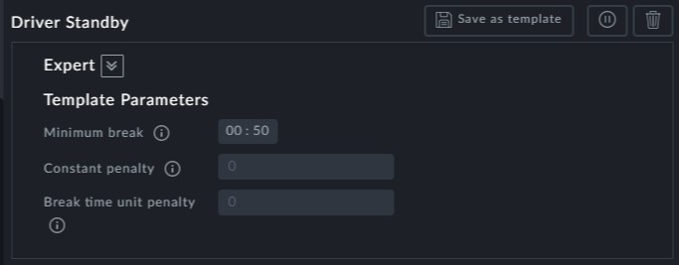

**Point to note:**

**Minimum break**: This is the minimum break that can incur a standby penalty



**Constant Penalty**: A fixed penalty incurred for each break over the minimum

**Break time unit penalty:** The penalty incurred for each minute of break time over

the minimum